PhD Dissertation:

MEASURING AND VISUALIZING URBAN MORPHOLOGY THROUGH INFORMATION ENTROPY THEORY

Descartes states "Divide each difficulty into as many parts as possible and necessary to resolve it." Deconstruction is not a new idea as demonstrated by Descartes quote but a compelling one for understanding the issues behind complex systems, especially as vast as cities. Built form is a relational process, and the overall spatial form emerges with a sense of wholeness, a certain degree of completeness, in its topologic embodiment. Using Alexander's 'levels of scale' property of wholeness as a morphologic translation interface, the method developed in this research allows questioning relational scaling formations among the built entities. Shannon's entropy theory has been employed for measuring the state of uncertainty, and disorderliness conveyed through the multivariate context of morpho-information across varying scales.

Urban design is an interdisciplinary approach to urban space. The critical role of urban design, between planning and architecture, is to set an order, a feeling of wholeness, and a scaling harmony in urban space (Konuk, 1992). The urban design approach in this definition is about concepts of order, hierarchy, and harmony in the process of making robust urban spaces. According to Hanson (1989), the order in its most largely approved definition is a notion of sameness, harmony, repetition, geometry, rhythm, symmetry, and grid.

Cities are about functions that are perfectly integrated into agglomerated layers of the built environment. Layers of different forms of spatial entities are seemingly complex but logically simple ways of scaling (Jiang B., 2012). Cities have their very own scaling patterns embedded in the multivariate morphologic formations. For so many reasons, scaling hierarchy in cities can be deformed through the time. Salingaros states that lively and vibrant cities accommodate different scaling regimes in touch with all their existing systems (Salingaros, 2005). A new need for automobile-led 20th-century urbanization and uncontrolled population growth in cities caused a disregard for the scaling-laws in cities and imposed piecemeal layouts and typological forms. This brought an inevitable change in scaling patterns of spatial formations and thus on their level of wholeness.

Cities are made of built entities that make the morphologic and symbolic character of spaces, and they create the evaluative and measurable qualities (Nasar, 1994). Large or small, built entities that create the morphologic character in cities are measurable. According to Jiang, geographic space is made of far more small things than large ones, and the scaling pattern can evoke a certain sense of wholeness (Jiang & Sui, 2013). This kind of wholeness and beauty was initially defined by C. Alexander and compiled in his masterwork "The Nature of Order" (Alexander, 2002-2005).

The interplay among built elements in different orders, in different size and scales, create the morphology. The order that emerges through such multiplicity of morphologic interplay comes to the front as a measurable notion. Shannon's information entropy, in this study, is being used as a method to measure the "relationship between order and disorder" (Arnheim, 1971). Use of Shannon's information entropy in the proposed method helps to measure various spatial occurrences in various adjacencies as information strips. The raw data, building footprints vector data, utilized in this study, comprises the top view images showing two-dimensional figure-ground relationships of built entities.

Morphologic interplay at various scale levels is a form of information conveyed through the units hypothesized to correlate with the degree of the wholeness of the morphologic system.

The concept of wholeness for a spatial context is a relational notion. It is a fragile relationality. Once a single entity that belongs to a built context changes, the configuration and the distribution of the information and thus the Entropy, of the system changes. This happens across different scales. Therefore, measuring the Entropy of a particular built context requires a multi-scalar approach. The multi-scalar approach in this research is being methodized through superimposing a grid with equivalent units upon the raw data. The grid units frame equivalent amounts of pixels and generate units of equal size. Each grid unit in each particular grid scale bounds a specific type of morphologic interplay. Changing the grid scale allows creating different size of grid units scanning different built formations exponentially and recursively.

The interplay between the built elements and their overall spatial content is in a continuous process of change. This kind of change in real space is a space compromise ending up in a gradual adaptation. Undoubtedly, if not a natural disaster, this is foremost a human-led process. The human factor, as the decision-maker, builds up the causality about the degree and intensity of the spatial change. Although it mostly occurs in the micro scale, the process of change and adaptation gradually remakes the overall urban built context. According to Baynes and Heckber (2009), understanding and modeling the dynamics of spatial change may lead to better understanding and management of the human process that leads to change.

Cullen in "Townscape" (Cullen, 1961) states that space is meaningful in its very own in-situ relationality. The spatial change also embodies and is perceived within such contextual relationality. This kind of relationality requires a site-specific approach for the near and related things that form a geographic context. Tobler, in his influential "First Law of Geography," states that everything is related to everything else; yet, the things that are close to each other are more related than the distant ones (Tobler, 1970). Miller (2004) on this issue, notes that measuring the space does not just generate simple metric or geometric findings, but also develops new spatial attributes considering the nearness and relatedness of numerous spatial issues. It allows measuring the geographic space through the interplay between diverse phenomena in various scales. Mathematical models in urban planning and design studies can give precise and accurate results by measuring inputs that embody urban space in an objective way (Nasar, 1997).

Built form is an adaptive and relational process where the overall spatial form emerges through a sense of wholeness in its very own topologic body. This research focuses on the question of how to measure this kind of relational wholeness that exists in the very embodiment of spatial occurrences across scales. The methodological approach to this question is developed through combining C. Alexander's theory of wholeness with C. Shannon's information entropy theory. Shannon's Entropy is a method of measuring the state of uncertainty and disorderliness through conveyed information.

Christopher Alexander, in this respect, has been one of the most influential theoreticians. He, in profound details, investigated if there are any recurrent geometric structural features whose presence in things are correlated with their degree of life or wholeness and defined fifteen structural patterns of wholeness.

Alexander's fifteen properties of wholeness, in his sketches in Figure 1.1 are:

(1) Levels of Scale, (2) Strong Centers, (3) Boundaries, (4) Alternating repetition, (5) Positive Space, (6) Good Shape, (7) Local Symmetries, (8) Deep Interlock and Ambiguity, (9) Contrasts, (10) Gradients, (11) Roughness, (12) Echoes, (13) The void, (14) Simplicity and Inner calm, and (15) Non-separateness. (Alexander C., 2002-2005, pp. 244-289)

Alexander asserts that the properties are the essential qualities in things that have lives. They are the elaborative explanations of the observations recorded in "Timeless Way of Building" (p242, 1979). Alexander (2002-2005), thinks that systems with more degree of wholeness may contain one, several or all of the fifteen properties in the same context in less or more densely intertwined ways.

Levels of Scale is the first and most coherent one of the fifteen properties of wholeness. In the proposed method, the algorithm designed for data acquisition has two primary functions. First, the property of Levels of Scale is being used as a morphologic translation interface, via a dynamic grid system with equivalent units that is superimposed upon a case study area's raw data. The raw data is the 2D building footprints vector data. The grid interface, parallel to the way that Alexander suggests in his theory of wholeness, principally enables each structural entity that falls into each grid unit to act as a center. Therefore, the grid can translate endless possibilities of morphologic formations into digitized data through the grid units. Depending on the size of the analyzed area and scale of the grid used for the analysis, any built area can be translated into tens, hundreds, or thousands of units by the grids of varying scales.

Briefly, Alexander's definition of wholeness implies that everything that gets together and embodies a system has a degree of wholeness not only to a particular scale but also for several others. In other words, starting from the nearest proximity, there is a unique hierarchy of size, scale, and shapes among the structural entities in geographic space. This is what embodies a unique form and sense of wholeness radiated. As a complex entity, the urban setting, in micro, mezzo and macro scales, has its legibility and this kind of relational embodiment requires an analytical investigation from the "relatedness" point of view across scales. Results have been hypothesized to correlate with the total degree of the wholeness of the analyzed areas.

Understanding the spatial structure and processes of the built environment is a challenging issue in urban planning. Despite extensive investigations on urban complexity, measuring the relative qualities embedded in spatial formations is still a topic with few advances. According to Kempf (2009), the only way to understand spatial complexity is by questioning the interactions of the constituting parts across scales. In so doing, we can grasp the multi-scalar structure of space through the interaction of its subcomponents (Alexander, 2002-2005).

According to Alexander, every single entity of a multitude of sizes and shapes are all centers, and they all together form a greater whole and a gradual scaling pattern upon the geographic space. Whatever we make in this kind of complexity is an activity that we transform the entire system of things, not an assembly of bits. This reminds us that there is a difference between "whole system theory of design" and "assembly theory of design" (Mehaffy & Salingaros, 2011). Not in all cases, we can treat a system in both ways. In other words, it is not convenient to treat system problems with both theories. A car's subcomponents, for instance, can be taken apart and reunited, and the car works. A living organism is never like this. We cannot detach the parts of a living organism and reunite it to make it live again. "The reason is that there is no way to decompose an organism into its parts without destroying the connective networks - subsystems - that make the whole system work" (Mehaffy & Salingaros, 2011). Alexander pioneered comprehensive thinking on wholeness and life in his masterwork "The Nature of Order" (Alexander C., 2002-2005).

Alexander's idea of "life" stands on a firm basis of holism and inseparable collectivism. The wholeness of a system is not about the quality and behavior of every single entity, what he calls "center," but the way they come together and make each other strong across scales. This implies an emerging and holistic understanding of wholeness about the relative size, shape, and density of centers. This was one of Alexander's major questions in seeking structural features that tend to be present in systems with more life (Alexander C., 2002-2005, p. 144). He thinks that everything that has wholeness also has life and vice versa. In this sense, he claims that "Life directly comes from the wholeness" (Alexander, 2002-2005, p106).

The question arises from the need for a scientific and provable definition of wholeness. Alexander himself also points to this need (Alexander, p28). It is evident that Alexander's definition of wholeness as a phenomenon is not independent of the concept of order. This is not a shallow understanding of the order that only exists in nature but everything. It is a quality says Alexander (Alexander, p28). It inherits and applies to every brick, every stone, and every physical structure of any kind that appears in space. Everything has its order and thus its way of life (Alexander, p28).

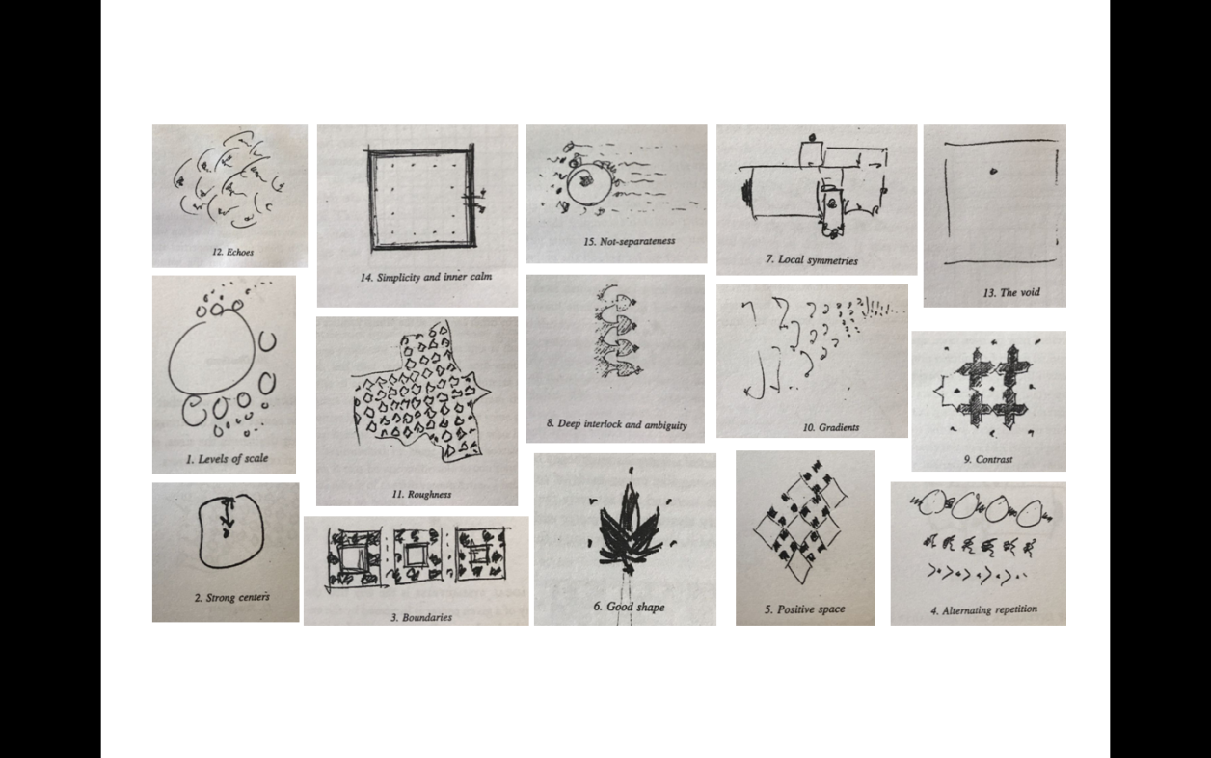

Figure 1. 1: Fifteen diagrams for Alexander's properties of wholeness and living centers (Alexander C., 2002-2005, p. 248).

"The things and the systems in the world which are most dead – most image-laden buildings, artifacts, the most sterile housing projects, the most damaged ecological systems, and the most poisoned streams - have these properties to the least degree" (Alexander C., 2002-2005, p. 236). Although Alexander's assertions require scientific confirmation, his references rely on natural systems that remind strong implications of life nested in nature. This approach, with a huge variety of functional and cultural content, may not be the most convenient analogy in explaining why the properties are supposed to impose wholeness. Cities are heterogeneous complexities. Density and dispersion of the properties in a spatial complexity may vary depending on culture, climate, and technology and so on. Yet, they all describe particular qualities that flourish in their own context.

This research raises the question of whether or not we can scientifically measure the degree of wholeness going in the spirit of Alexander's definition of wholeness for spatial complexities. To do that, this study incorporates develops Alexander's "Levels of Scale" (Alexander C., 2002-2005, p. 246) property of wholeness with "Shannon's Information Entropy" (Shannon, 1948) theory in the development of the data-mining function of the method.

Alexander's Levels of Scale property is the reference data-mining rule employed in the proposed method. There is ultimately no holistic structure between fifteen properties that allow an actual whole to unfold. The great irony of the fifteen properties is that they can work as piecemeal components of a bigger complex system. Therefore, an alternative approach mediating the properties and their spatial complexities is necessary to define a rule-dependent data-mining capacity for translating urban topology in a holistic way. Levels of Scale tends to tie up several properties such as 'Gradient,' 'Alternating Repetition,' 'Echoes' and 'Non-Separateness' together by modified yet highly similar scaling logic. Therefore, it has been selected as the parameter rule for the data-mining process in the proposed method.

Entropy concept, a scientific measure largely used in many different fields, is far from its initial arising in physics. Although Shannon's seminal paper "A Mathematical Theory of Communication" (1948) in information science has no more common theoretical basis for the second law of thermodynamics, Shannon's Entropy has become a strong reference in applied science. Shannon's Entropy briefly states that information can be measured in relation to the distribution of positional figures embedded in a conveyed information (Bailey, 2015), (Leibovici, 2009), (Shannon, 2001).

This study develops a mathematical model of wholeness through generating the Entropy for particular scale levels by using the building footprints raw data specific to a particular area. The core function of the scale in the information retrieval process is to set a dynamic grid interface with equivalent units upon a particular area's raw data that is orthographic satellite imagery as in Figure 1.0. In other words, for each scale level, the area is superimposed by a grid system with equivalent units as in Figure 1.2. The size of each grid unit is dependent on the number of pixels that are framed and specific for each scale level as in Figure 1.2. Each unit frames a specific pixel density and thus a certain morphologic formation. A particular grid scale briefly refers to a certain amount of pixels framed in each scale level; thus, a specific entropy value for each unit is generated as a response to the morphologic formation that is framed.

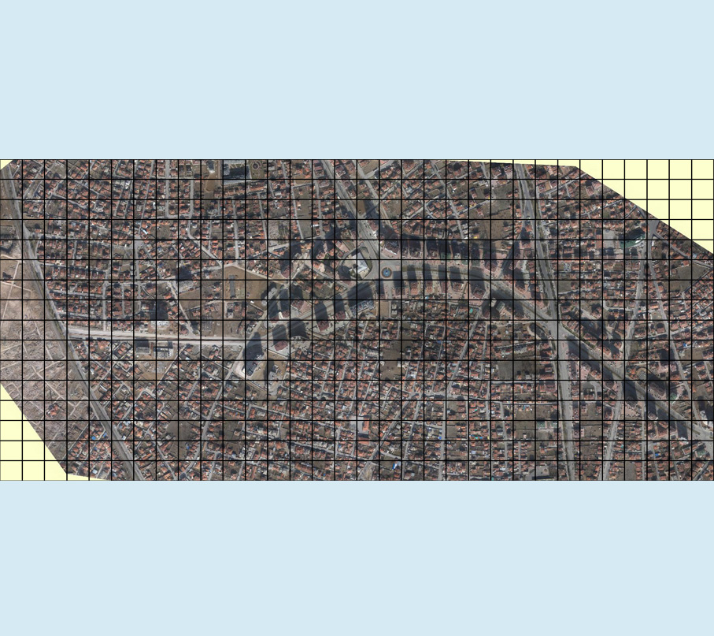

Figure 1.0: Ortographic satellite imagery as the raw data superimposed by a dynamic (changable) grid system for the data extraction

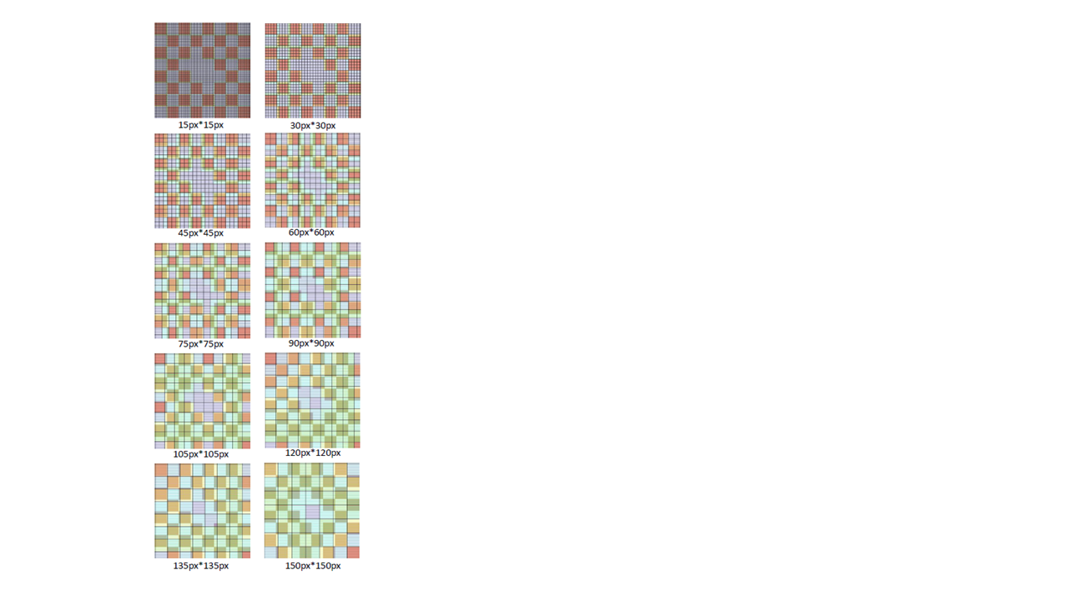

Figure 1. 2: Grid with equivalent units depending on the selected grid scale.

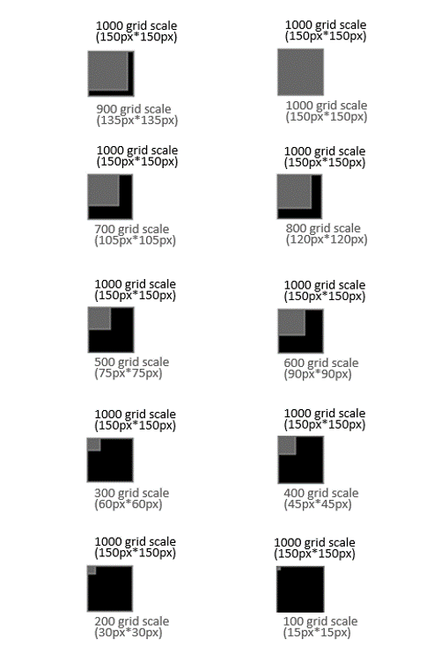

Figure 1.3: Pixels framed by each grid unit in each grid scale level.

This study develops an alternative quantifiable approach that can illustrate and measure the relational nature of wholeness in urban built areas from the Levels of Scale point of view. To achieve it, a spatial analysis tool has been developed. The tool has two primary functions: (1) Data-mining and (2) Data-visualization. The data-mining function has been developed by compiling several image processing algorithms, compiling 'in range - edge - canny - color filter algorithms' (Opencv, 2017) on C# to retrieve data by a hybrid feature extraction algorithm out of building footprints vector data. Data-visualization function, developed in Processing, visualizes the retrieved entropy value sets and illustrates the outcomes of the analysis.

The proposed method in this study, as an explorative approach, attempts to reveal the bottom-up nature of urban morphologic emergence in a multi-scalar way. This effort aims to unearth and illustrate the degree of scale-dependent wholeness for a particular selected built context using Shannon's entropy concept. Levels of Scale, in this sense, acts as a parameter rule in information retrieval.

This study hypothesizes that morphologic formation in cities is a significant element of spatial signature. Regarding the causation between disorder and information entropy theory, the entropy value for a particular scale might define a degree of wholeness for spatial formations. The raw data used for the case areas in this study is the building footprints vector data.

Scope and limitations

It is due to our cultural context, maybe even due to our natural state of being alive, that we admit more value to life than a machine. The distinction between machine and life boils down to the question of reproducibility. What makes a car a machine? Is it the fact that humans can disassemble and reassemble it? Is it too simple to be a system that has more value than the sum of its parts? There are a couple of reasons why a living organism dies when disassembled. First, we are not able to disassemble without destroying it irrevocably. Second, a living organism can be seen as an ongoing self-maintaining process.

Once stopped, it would need to restart from the very first cell division to become alive again. That is how we reproduce ourselves. Mehaffy and Salingaros (2011) state that there is no way to decompose an organism into its parts without destroying the connective networks – subsystems - that make the whole system work.

There are pros and cons of applying the notion of a 'living' and therefore biological organism to a city. One concern to point out here is: Can we reassemble a city along the lines of a biological organism? Practically, we can. The degree of life about the city would not be the same as before, but there would be a life. Even in a city that has not been destroyed and reassembled, public life changes every day. Therefore, there is a loose relationship between wholeness and life. The notion of wholeness is too closely tied to the concept of life. It has been asked at what point a human being mentally and physically conceives itself as a whole. There are so many ways of being incomplete as a person and still being alive, that the entire question of wholeness is a large, flexible and not so clear phenomenon. In the Middle Ages, a city without a city wall to protect it was not considered to be a city. This reminds that the entire definition of spatial wholeness and so the notion of "living structure" appears to be a matter of time, space and cultural relevancy.

Even a catalog of the fifteen properties that Alexander structurally defines for his definition of wholeness does not sound complete. It becomes misleading when conceiving wholeness as a solely physical property. Either spatial or functional, wholeness, as an urban spatial quality, requires a comprehensive examination of physical, cultural and mental qualities what makes a 'city.' Therefore, questioning the notion of wholeness out of two-dimensional spatial data, through referencing Alexander, is formally correct yet a debatable attempt.

The place is an adaptive cultural process (Rapoport, 2017). It may be incomplete or imperfect and yet can have a life. Adapted to spatial analysis, the question might be phrased as: "how whole" or "how complete" is a space or an area based on the information conveyed through its various, multi-scalar, morphologic possibilities. Shannon's entropy (1948), (2001) as a measure of uncertainty for conveyed morphologic information, is a consistent way to apply as the core data mining method in this study.

Being alive in biological terms is a binary matter. There are only two major degrees, dead or alive, and no other states of existence. In space, there are varying degrees of completeness or incompleteness, and this study hypothesizes that it is a measurable concept beyond intuition (Alexander C., 2002-2005). Karaali and Karagol (2013) define spatial incompleteness as evocative of liminal states, such as circumstances annoying the user, dissonant matches, uncertain situations, ambiguous formations, and undefined regions. Adapted to spatial analysis, there are varying degrees of completeness or incompleteness in the built environment and this study, using Shannon's information entropy theory, demonstrates that wholeness or completeness as the spatial quality is a measurable notion.

The concept of wholeness and the life of a spatial setting is a broad notion, and the connection between two concepts is controversial. Building definitive and conclusive analogical bridges between wholeness and life is not always as Alexander implies and claims in several ways. The entire question of wholeness is a large, flexible, and not so clear phenomenon, and there is a loose relationship between wholeness and life (Ekinoglu & Kubat, 2017). In other words, beyond strict definitions of "dead" and "alive" life can exist in various degrees in between those two in space. Nevertheless, it is hard to construct a direct and determinant relationship between two concepts since different levels of life can exist in space with various degrees of wholeness.

The idea of wholeness and life in space requires a profound and site-specific investigation considering various site-specific cultural, social, symbolic ingredients, and architectural style. Therefore, reducing the concept of wholeness merely to the relationships of the sub-constituents of a built system's layout might be highly limiting. In order to avoid this shortfall, in this study, the concept of wholeness that Alexander depicts is being referred as a quality of "completeness" that emerges through the relationships among the sub-constituents or the parts and whole relationships of the system. Moreover, Alexander's overall idea of wholeness and life also stands on a firm basis of completeness (Ekinoglu & Kubat, 2017). In brief, from this perspective, the proposed method as an evidence-based topologic investigation is a promising approach to shed light on an analytical assessment of morphologic possibilities and change scenarios.